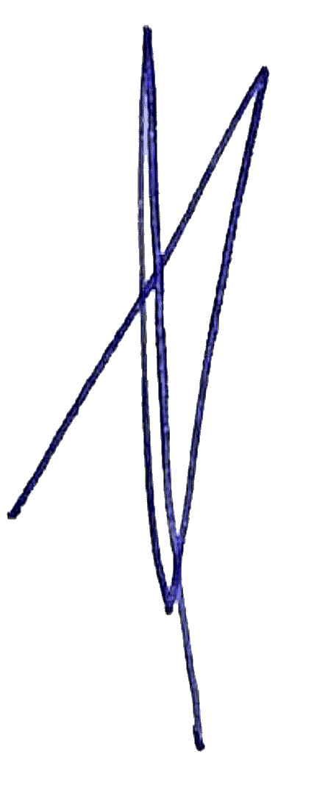

Sieg Maré

Director / Legal Practitioner

Phone: (08) 9792 4451

Email: sieg.mare@workwiseadvisory.com.au

Address: Unit B/29 Bonnefoi Blvd, Bunbury, 6233

[www.workwiseadvisory.com.au](http://www.workwiseadvisory.com.au)

